**COMPLEX NUMBERS**

**LAB # 05**



**CSE301L Signals & Systems Lab**

Submitted by: **Shah Raza**

Registration No: **18PWCSE1658**

Class Section: **B**

“On my honor, as a student of University of Engineering and Technology, I have neither given nor received unauthorized assistance on this academic work.”

Student Signature: ______________

Submitted to: **Engr. Durr-e-Nayab**

Wednesday, June 24th, 2020

**Department of Computer Systems Engineering**

**University of Engineering and Technology, Peshawar**

**Lab Objectives:**

Objectives of this lab are as follows:

* Gain familiarity with Complex Numbers and plot them
* Complex exponential signals
* Real exponential signals

**Task # 1:**

Write matlab function zprint, which takes a complex number and returns it real part, imaginary part, magnitude, phase in radians, and phase in degrees.

**Problem Analysis:**

In order to find the real part, imaginary part, magnitude and phase we use functions like, real(), imag(), abs() and angle().

**Code:**

function zprint(comp)

disp('Z = X + jY Magnitude Phase Ph(deg)');

disp('Real Part: ');

disp(real(comp));

disp('Imaginary Part: ');

disp(imag(comp));

disp('Magnitude : ');

disp(abs(comp));

disp('Phase Angle: ');

disp(angle(comp));

disp('Ph(deg): ');

disp(angle(comp)*57.5);

end

**Output:**

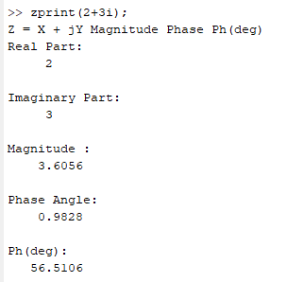

**Task # 2:**

Compute the conjugate ź and the inverse for any complex number z. Display the results numerically with zprint.

**Problem Analysis:**

In order to find z conjugate use the function conj() and find z inverse by dividing 1 by z.

**Code:**

z=2+3*i;

z_conj=conj(z);

z_inv=1/z;

disp('For z_conj: ');

zprint(z_conj);

disp('For z_inv: ');

zprint(z_inv);

**Output:**

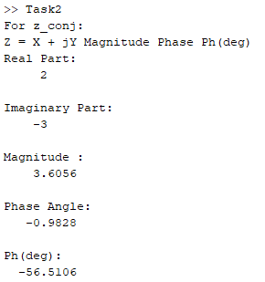 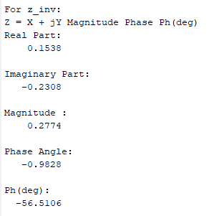

**Task # 3:**

Take two complex numbers and compute z1 +z2 and display the results numerically using zprint.

**Problem Analysis:**

Simply add both the complex numbers and use zprint function to display them.

**Code:**

Z1=2+3*i;

Z2=4+65*i;

Z3=Z1+Z2;

disp('Z3: ');

zprint(Z3);

**Output:**

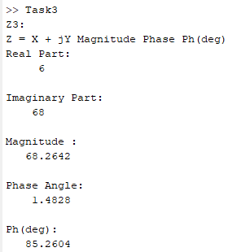

**Task # 4:**

Take two complex numbers and compute z1z2 and z1/z2. Use zprint to display the results numerically.

**Problem Analysis:**

Simply multiply and divide both the complex numbers and use the zprint function to display them.

**Code:**

Z1=2+3*i;

Z2=4+5*i;

Z3=Z1*Z2;

disp('For Z3: ');

zprint(Z3);

Z4=Z1/Z2;

disp('For Z4: ');

zprint(Z4);

**Output:**

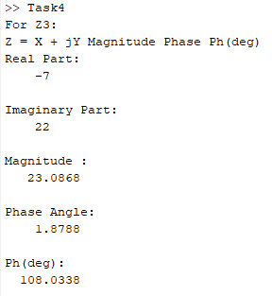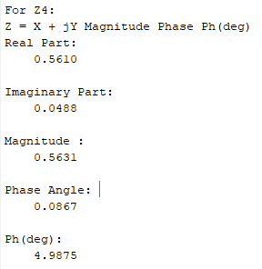

**Task # 5:**

Determine the complex conjugate of the exponential signal given and plot its real and imaginary portions.

**Problem Analysis:**

Take conjugate of the given signal and plot it along with the original signal in order to observe the difference. As conjugate only affects the imaginary part, the real part stays the same.

**Code:**

t=0:1/10:10;

w=pi/2;

A=5;

X=A*exp(w*t*i);

X1=conj(X);

subplot(2,1,1)

stem(t,real(X),'filled');

hold on;

stem(t,real(X1),'filled');

title('Real part');

xlabel('X-axis');

ylabel('Y-axis');

subplot(2,1,2)

stem(t,imag(X),'filled');

hold on;

subplot(2,1,2)

stem(t,imag(X1),'filled');

title('Imaginary Part');

xlabel('X-axis');

ylabel('Y-axis');

**Output:**

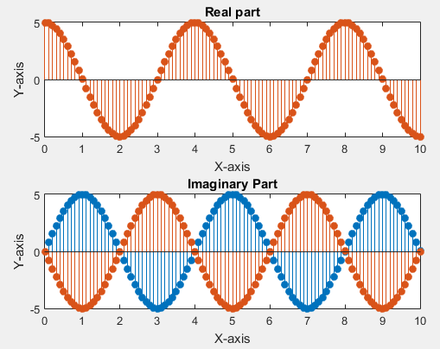

**Task # 6:**

Generate the complex valued signal:

**y(n) = exp (-0.2 + j0.5)n, ‐10≤n≤10**

plot its magnitude, phase, the real part, and the imaginary part in separate subplots.

**Problem Analysis:**

Use functions to find magnitude, phase, real and imaginary parts of the given signal and plot them.

**Code:**

t=-10:0.5:10;

X=1*exp(-0.2+0.5*i)*t;

subplot(4,1,1);

stem(t,abs(X),'filled');

title('Magnitude');

subplot(4,1,2);

stem(t,angle(X),'filled');

title('Phase');

subplot(4,1,3);

stem(t,real(X),'filled');

title('Real Part');

subplot(4,1,4);

stem(t,imag(X),'filled');

title('Imaginary Part');

**Output:**

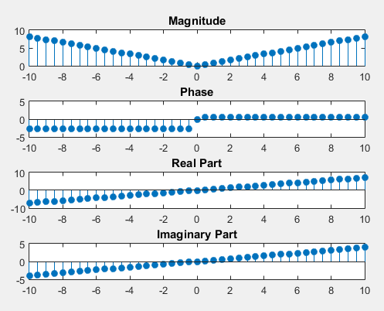

**Task # 7:**

Generate a real‐exponential x=an for a=0.7 and n ranging from 0‐10. Find the discrete time as well as the continuous time version of this signal. Plot the two signals on the same graph. Repeat the same program with a value of a=1.3.

**Problem Analysis:**

To find discrete time signals use stem function and for continuous time signal use plot function.

**Code:**

n=0:10;

a=0.7;

X=power(a,n);

subplot(2,2,1);

stem(n,X,'filled'); %Discrete

title('For a=0.7');

subplot(2,2,2);

plot(n,X); %Continuous

title('For a=0.7');

a=1.3;

X=power(a,n);

subplot(2,2,3);

stem(n,X,'filled'); %Discrete

title('For a=1.3');

subplot(2,2,4);

plot(n,X); %Continuous

title('For a=1.3');

**Output:**

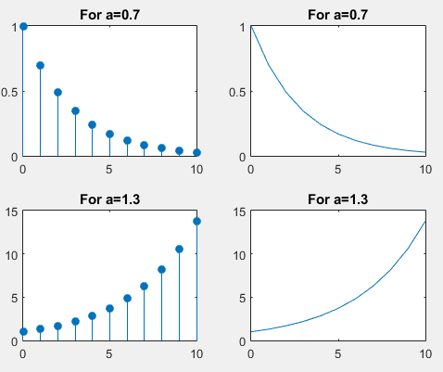

**Task # 8:**

Multiply the two discrete signals x1=5exp(i*n*pi/4) and x2= an. Plot the real as well as the exponential parts for 0<a<1 and a>1.

**Problem Analysis:**

Take two values of ‘a’ in the specified ranges and calculate the signal for both then multiply both the signals and plot them.

**Code:**

t=0:0.15:5;

X1=5* exp(pi/4*t*i);

a=0.5;

X2=power(a,t);

X3=X1.*X2;

a=2;

X4=power(a,t);

X5=X1.*X4;

subplot(4,1,1);

stem(t,real(X3),'filled');

title('Real Part (0<a<1)');

subplot(4,1,2);

stem(t,imag(X3),'filled');

title('Imaginary Part (0<a<1)');

subplot(4,1,3);

stem(t,real(X5),'filled');

title('Real Part (a>1)');

subplot(4,1,4);

stem(t,imag(X5),'filled');

title('Imaginary Part (a>1)');

**Output:**

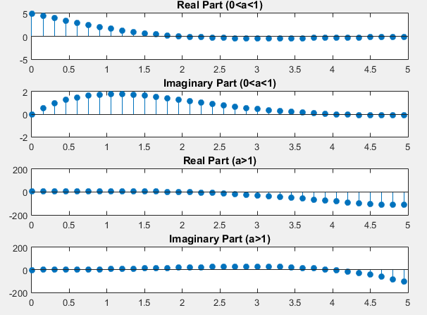

**Task # 9:**

Plot the discrete signal x=a^|n| for n ranging from ‐10 to 10. Draw two subplots for 0<a<1 and a>1.

**Problem Analysis:**

Take two values of ‘a’ in the specified ranges and calculate the signal for both and plot them.

**Code:**

t=-10:0.5:10;

a=0.5;

x1=power(a,abs(t));

a=2;

x2=power(a,abs(t));

subplot(1,2,1);

stem(t,x1,'filled');

title('for 0<a<1');

subplot(1,2,2);

stem(t,x2,'filled');

title('for a>1');

**Output:**

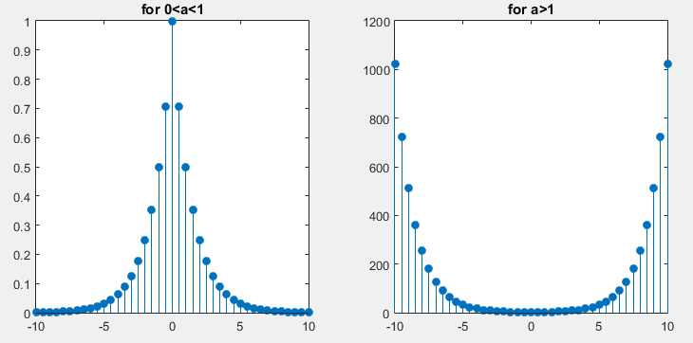

**Task # 10:**

Generate the signal x(t) = Aej(ωt + π) for A = 3, π= ‐0.4, and ω = 2π(1250). Take a range for t that will cover 2 or 3 periods. Plot the real part versus t and the imaginary part versus t.

**Problem Analysis:**

Take the given values and put them in the equation, calculate and plot the real and imaginary parts of the signal.

**Code:**

t=0:0.05:4;

A=3;

p=-0.4;

w=2*p*(1250);

X=A*exp(i*(w*t+p));

subplot(2,1,1);

stem(t,real(X),'filled');

title('Real Part');

subplot(2,1,2);

stem(t,imag(X),'filled');

title('Imaginary Part');

**Output:**

